16.55: The shower stall can be modeled as a pipe closed at both ends, and hence there are nodes at the two end walls. Figure (15.23) shows standing waves on a string fixed at both ends but the sequence of harmonics is the same, namely that an integral number of half wavelengths must fit in the stall.
a) The condition for standing waves is 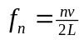, so the first three harmonics are n = 1, 2, 3.
b) A particular physics professor’s shower has a length of 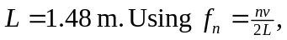 the resonant frequencies can be found when 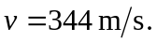

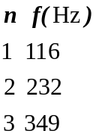

Note that the fundamental and second harmonic, which would have the greatest amplitude, are frequencies typically in the normal range of male singers. Hence, men do sing better in the shower! (For a further discussion of resonance and the human voice, see Thomas D. Rossing , The Science of Sound, Second Edition, Addison-Wesley, 1990, especially Chapters 4 and 17.)

